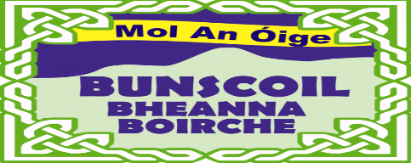

COVID-19 POLICY
Bunscoil Bheanna Boirche is dedicated to providing a healthy and safe work environment for our staff and a safe learning environment to nourish our pupils. To ensure this we have developed a COVID-19 plan. The School Management and whole school staff are all responsible for implementing this plan and the collective effort made by all will help stop the spread of the virus.
We intend to:
- continue to monitor our response to COVID-19 and amend this plan in consultation with staff;
- follow up-to-date public health advice and guidance from the PHA, HSE and DE
- display information about COVID-19 and how to effectively wash your hands in the school;
- inform all staff and pupils about the expectations for good hygiene, especially respiratory hygiene and social distancing, where possible;
- rearrange the layout of the school to provide additional opportunities for social distancing and less opportunities for interaction among ‘protective bubbles’;
- keep and maintain a log book of visitors to the school to assist with track and tracing
- implement and follow the agreed process for a member of staff or pupil who shows symptoms of COVID-19
- inform staff and pupils of what to do if they show symptoms of COVID-19 while at school;
- ensure regular, enhanced cleaning is done throughout the school day, and recorded;
Staff will be consulted regularly and feedback, suggestions or concerns welcomed. This can be done through the Principal.

Síniú: _ Aingeal Nic an tSábhaisigh __ Dáta: __ 24/08/19 __
(Príomhoide)

Síniú: _A. Goodwin Dáta: ___ 24/08/20 __
(Cathaoirleach na nGobharnóirí)

